Software Requirements Specification

for

Awakaza Hotel Management System

Version 1.0 Approved

Prepared by Team SudoCoders

Faculty of Information Technology

University of Moratuwa

01.01.2023

Table of Contents

1 Introduction 1

1.1 Purpose 1

1.2 Document Conventions 1

1.3 Intended Audience and Reading Suggestions 1

1.4 Product Scope 1

1.4.1. Problem in Brief 2

1.4.2. Aim and Objectives 2

2 References 3

EER Diagram: 3

OOAD Diagrams: 3

3 Overall Description 4

3.1 Product Perspective 4

3.2 Product Functions 4

3.3 User Classes and Characteristics 5

3.4 Operating Environment 6

3.5 Design and Implementation Constraints 6

3.6 User Documentation 7

4 External Interface Requirements 8

4.1 Hardware Interfaces 8

4.2 Software Interfaces 9

5 System Features 10

5.1. Login 10

5.1.1. Description and Priority 10

5.1.2. Functional Requirements 10

5.2. Admin operations 10

5.2.1. Description and Priority 10

5.2.2. Functional Requirements 10

5.3. Front Office Front Operations 11

5.3.1. Description and Priority 11

5.3.2. Functional Requirements 12

5.3. Front Office Back Operations 12

5.3.1. Description and Priority 12

5.3.2. Functional Requirements 13

5.3. Housekeeping and Mini bar 13

5.3.1. Description and Priority 13

5.3.2. Functional Requirements 13

6 Other Nonfunctional Requirements 14

6.1 Performance Requirements 14

6.2 Security Requirements 14

7 Appendixes 15

7.1. Appendix A: User Interfaces 15

Table of Figures

Figure 4.1: User Login Portal 8

Figure 4.2: Overall Dashboard 9

Figure 7.1: Administration Portal 1 15

Figure 7.2: Administration Portal 2 15

Figure 7.4: Administration Portal 3 16

Figure 7.3: Administration Portal 4 16

Figure 7.5: Administration Portal 5 17

Figure 7.6: Administration Portal 6 17

Figure 7.7: Front office back ops 1 18

Figure 7.8: Front office back ops 2 18

Figure 7.9: Front office back ops 4 19

Figure 7.10: Front office back ops 3 19

Figure 7.11:Front office back ops 5 20

Figure 7.12: Front office back ops 6 20

Figure 7.13: Housekeeping 1 21

Figure 7.14: Housekeeping 2 21

Figure 7.15:Housekeeping 3 22

Figure 7.16: Billing 1 22

Figure 7.17: Billing 3 23

Figure 7.18: Billing 2 23

Figure 7.19: Room Management 24

Figure 7.20: Front office front ops 1 24

Figure 7.21: Front office front ops 3 25

Figure 7.22:Front office front ops 2 25

# Introduction

## 1.1 Purpose

The main goal of this document is to note down specifics of requirements then functionalities of the Awakaza Hotel Management System. It includes a thorough explanation of all the criteria for this tool's external interface, both functional and nonfunctional. This document will also give a thorough explanation of how this tool can be used to replace the current system and simplify tasks for project managers who will be utilizing it.

## 1.2 Document Conventions

IEEE 830-1998 standard for writing SRS document was used in writing this SRS document

## 1.3 Intended Audience and Reading Suggestions

In our context, this document is targeted towards the CircleBook Pvt Ltd Company and the university academic staff who are supervising the L02 projects of IT faculty of University of Moratuwa.

## 1.4 Product Scope

Awakaza is Cloud Based Software as a Service Platform developed By Circlebook (Pvt) Ltd that provides an intriguing alternative to standard software installation in the business environment (traditional model), where you must build the server, install the application, and configure it. Instead, the applications reside on a remote cloud network accessed through the web or an API, and it works like a rental. In this case, organization has the authorization to use it for a period and pay for the software that they are using.

There are couple of candidates from the West when choosing hotel management systems in the market. But, they are not compatible with the Hotels in Asian countries. And they are very high cost. This Hotel Management system is intended as an addition to the Awakaza platform. The system would be hosted on the cloud and run according to the concept of SaaS(Software as Service).

### 1.4.1. Problem in Brief

When choosing hotel management systems, all available candidates are very high cost and incompatible with hotels in Asian countries. There is a requirement for a Hotel Management System which is tailored to a hotel in a country like Sri Lanka and is affordable. Even medium-scale hotels should be able to afford the system.

### 1.4.2. Aim and Objectives

#### 1.4.2.1. Aim

The aim of this project is to develop an affordable SaaS, hotel management system tailored to use in medium to large scale hotel in a country like Sri Lanka.

#### 1.4.2.2. Objectives

Facilitates providing real time information of all domains of the Hotel

Facilitates administration of users of the system

Facilitates Supervision of House Keeping Operations and Mini Bar

Facilitates management of Front Office Front Operations

Facilitates management of Front Office Back Operations

Facilitates Reservations management and room operations

Facilitates automatic bill creation

Facilitates Kitchen supply management

# References

<https://awakaza.com>

## EER Diagram:

<https://uniofmora-my.sharepoint.com/:i:/g/personal/pitigalapkdgd_20_uom_lk/EdCewSJkI4lJliQY3Pe34dIBetQtsfo-jzCpYYLDURxQLg?e=OPL9IY>

## OOAD Diagrams:

<https://uniofmora-my.sharepoint.com/personal/pitigalapkdgd_20_uom_lk/_layouts/15/onedrive.aspx?id=%2Fpersonal%2Fpitigalapkdgd_20_uom_lk%2FDocuments%2F2nd%20Year%20Project%2FInterim%2FOOAD%20diagrams%20PDF&ga=1>

# Overall Description

## 3.1 Product Perspective

Awakaza Hotel Management system is supposed to be the next addition to the SaaS platform of Awakaza. This system should store the latest data of all the domain of the hotel and provide information in real time to all interested internal parties efficiently. Full project covers all the eight domain of a hotel, but phase one covers five.

* Front office front operations– Phase 01
* Front office Back operations – Phase 01
* House keeping – Phase 01
* Food and beverages and Billing– Phase 01
* Kitchen
* Engineering
* Purchasing
* Accounts
* Marketing

## 3.2 Product Functions

Main functions of the systems would be,

* User management
* User login
* User privileges management using user roles
* Hotel Chain management
* Locators management
* GRC management
* Guest Profile management
* Profile share
* Reservations management
* Meal plan management
* Automatic bill creation using stored data
* Bill layouts
* House keeping Room cleaning lists generation
* House keeping Room supervisor checklist generation
* House keeping mini bar management
* Discounts management
* Bill split and layouts

## 3.3 User Classes and Characteristics

We can differentiate users based on technical expertise.

* Very Low
  + Managers
  + House Keeping staff
* Medium
  + Receptionist
  + FnB operators
  + Other Data operators
* High
  + System Administrator

We could also classify based on the frequency of use.

* Low
  + Managers
* Medium
  + House Keeping staff
  + System Administrator
* High
  + FnB Operators
* Very High
  + All other data operators including receptionist

## 3.4 Operating Environment

The website would be ideally hosted on a linux machine on the cloud. At initial stage requirements would be,

* OS: Amazon Linux 2/RedHat Linux 8 with GUI disabled
* RAM: 8GB
* CPUs/vCPUs: 4

When the traffic increases, a load balancer should be used and we could horizontally scale the software into multiple instances with round robin policy in AWS.

## 3.5 Design and Implementation Constraints

The development would be done on team members’ laptops. Damages and technical issues with the laptops may slow down the contribution from a particular member. Due to the current situation in Sri Lanka repairing the laptops or replacing them may not be e e an option. This would pose many risks to the process.

## 3.6 User Documentation

A training session for the system will be organized with clients initially and a well-structured documentation will be handed in when subscribing to the Awakaza hotel management system. Clients can request onsite training sessions.

# External Interface Requirements

## 4.1 Hardware Interfaces

System accessed by the users through a web browser. Any device with a browser can access the system. Dashboards will be loaded after user logs in.

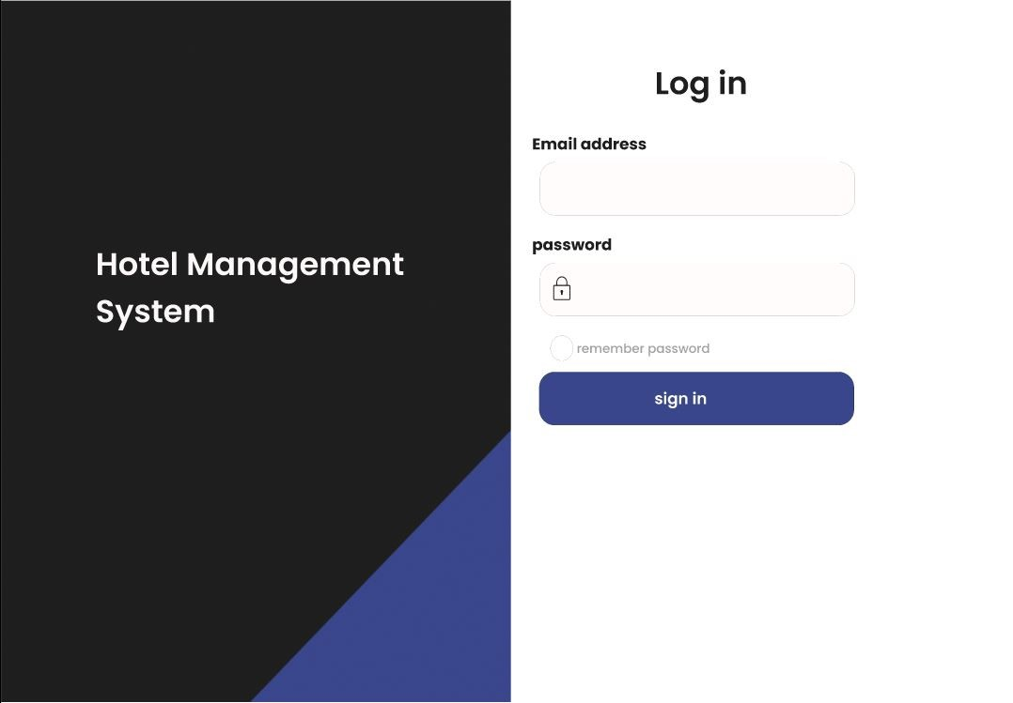

Figure .: User Login Portal

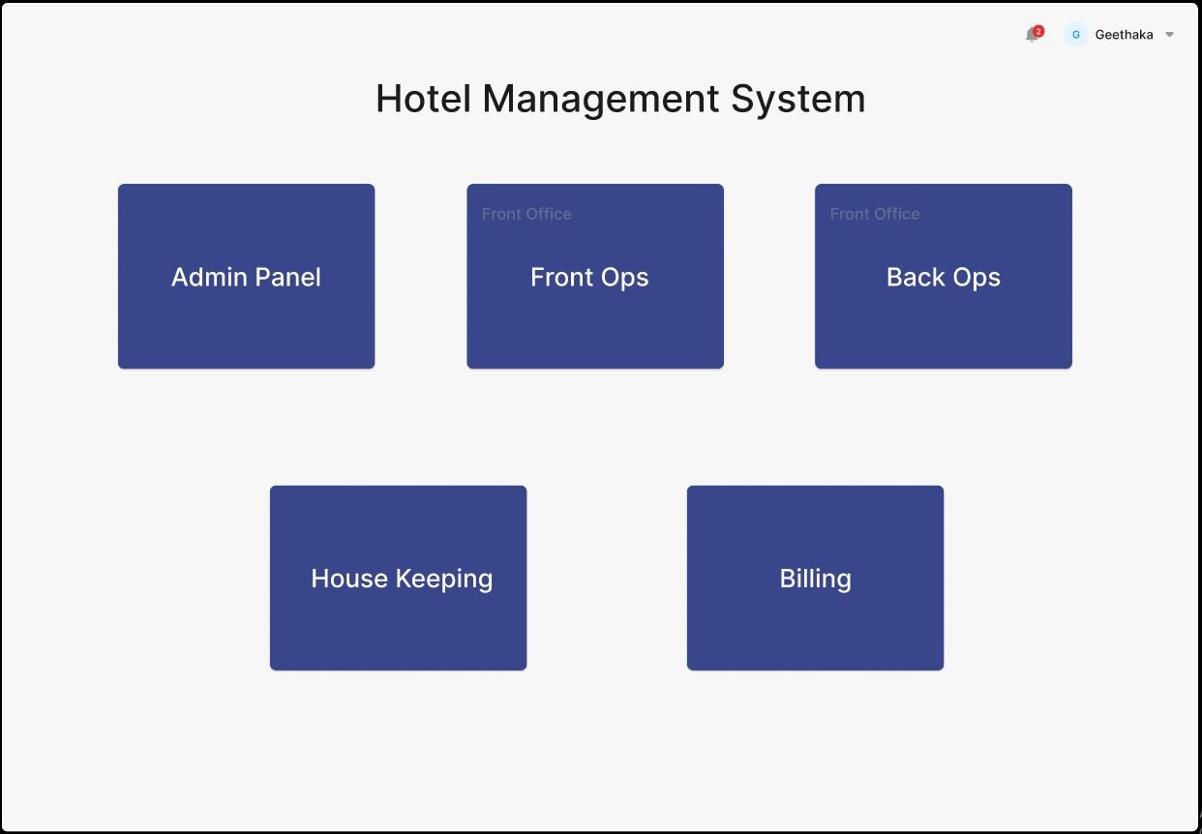

Figure .: Overall Dashboard

## 4.2 Software Interfaces

The system interfaces with MariaDB relational Database to maintain its data. In initial stages the same computer could be used to host the database and the website. When scaling out, a separate computer to host the database would be needed.

There is no direct interface with the operating system except as a platform to run the software on.

After phase one completion, the Hotel Management should be integrated with other Awakaza systems such as the POS, PMS.

# System Features

This section provides an example of how to group the functional needs for the product according to system characteristics, or the main services the product offers.

## 5.1. Login

### 5.1.1. Description and Priority

High priority and a must have feature.

### 5.1.2. Functional Requirements

REQ-1: The user should be allowed to go to the relevant dashboard based on his/her user role.

REQ-2: The user can reset the password.

## 5.2. Admin operations

### 5.2.1. Description and Priority

High priority, must-have feature. Administration of all the objects and users in the system.

### 5.2.2. Functional Requirements

User Management and Privileges

REQ-3: View Admin Dashboard

REQ-4: Add user

REQ-5: Edit user

REQ-6: Disable user

REQ-7: Delete user

REQ-8: Assign user role

Locators’ management

REQ-9: Add Locator

REQ-10: Delete Locator

REQ-11: Edit Locator

Rooms details management

REQ-12: Add Room

REQ-13: Delete Room

REQ-14: Edit Room details

## 5.3. Front Office Front Operations

### 5.3.1. Description and Priority

High priority and must-have feature. Manages all the front office operations of the hotel.

### 5.3.2. Functional Requirements

Guest Registration Card Management (GRC)

REQ-15: Add Guest Registration Card

REQ-16: Edit Guest Registration Card

REQ-17: Delete Guest Registration Card

REQ-18: Set Locator Value

Guest Profile Management

REQ-19: Add Guest Profile

REQ-20: Edit Guest Profile

REQ-21: Delete Guest Profile

## 5.3. Front Office Back Operations

### 5.3.1. Description and Priority

High priority and must-have feature. Manages all the back-office operations of the hotel such as reservations.

### 5.3.2. Functional Requirements

Reservations Management

REQ-22: Create Reservation

REQ-23: Edit Reservation

REQ-24: Cancel Reservation

REQ-25: Create Meal Plan

REQ-26: Edit Meal Plan

REQ-27: Add discount

## 5.3. Housekeeping and Mini bar

### 5.3.1. Description and Priority

High priority and must-have feature. Manages all the housekeeping and mini bar operations of the hotel.

### 5.3.2. Functional Requirements

Housekeeping

REQ-28: View dashboard

REQ-29: Generate rooms to be cleaned

REQ-30: Mini bar Dashboard

# Other Nonfunctional Requirements

## 6.1 Performance Requirements

Since this is an information system, the database should work with the lowest latency. Database on the same machine as the website could be a plus point in that context when the traffic is low. We can implement a load balancer to handle the traffic when it increases. Mechanisms such as caching (like Redis) could be implemented in the next phases after the system builds up traction.

## 6.2 Security Requirements

Guest data privacy and security is one of utmost importance when it comes to hotels. The instance which hosts the website should be hardened according to CIS standards to minimize operating system vulnerabilities and SELinux should be in enforcing mode. System access should be granted carefully by the system administrator.

# Appendixes

## 7.1. Appendix A: User Interfaces

Administration Panel

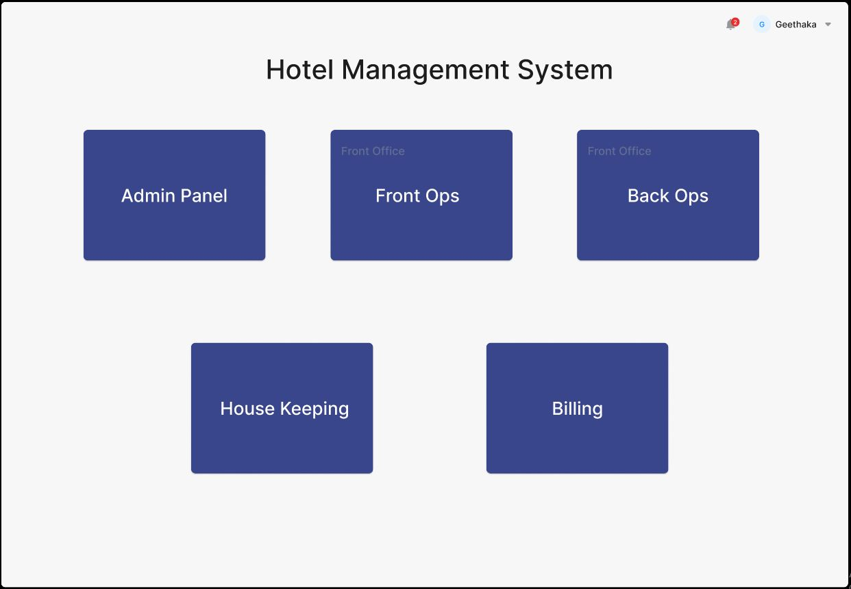

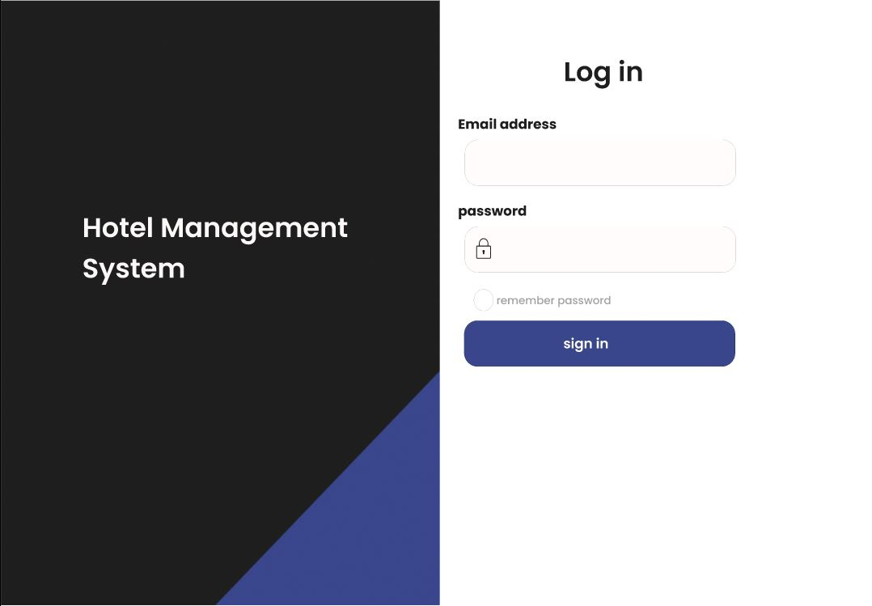Figure .: Administration Portal 1

Figure .: Administration Portal 2

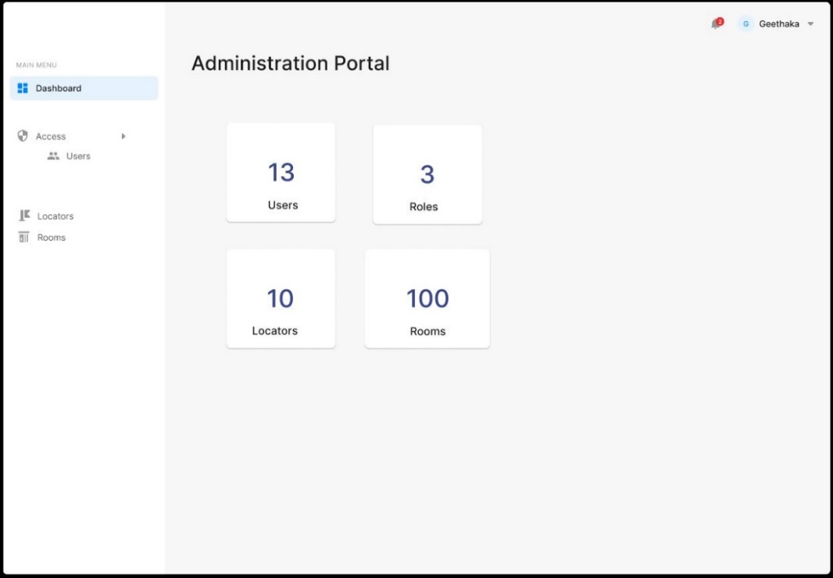

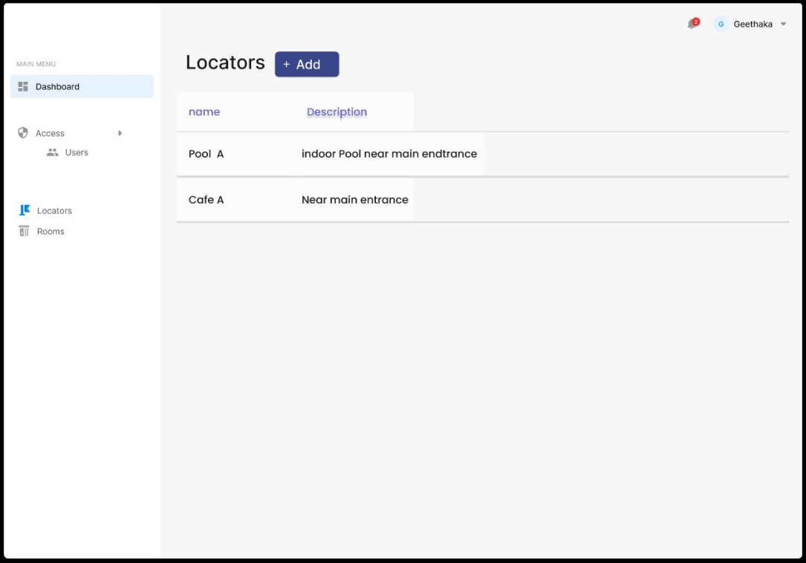Figure .: Administration Portal 3

Figure .: Administration Portal 4

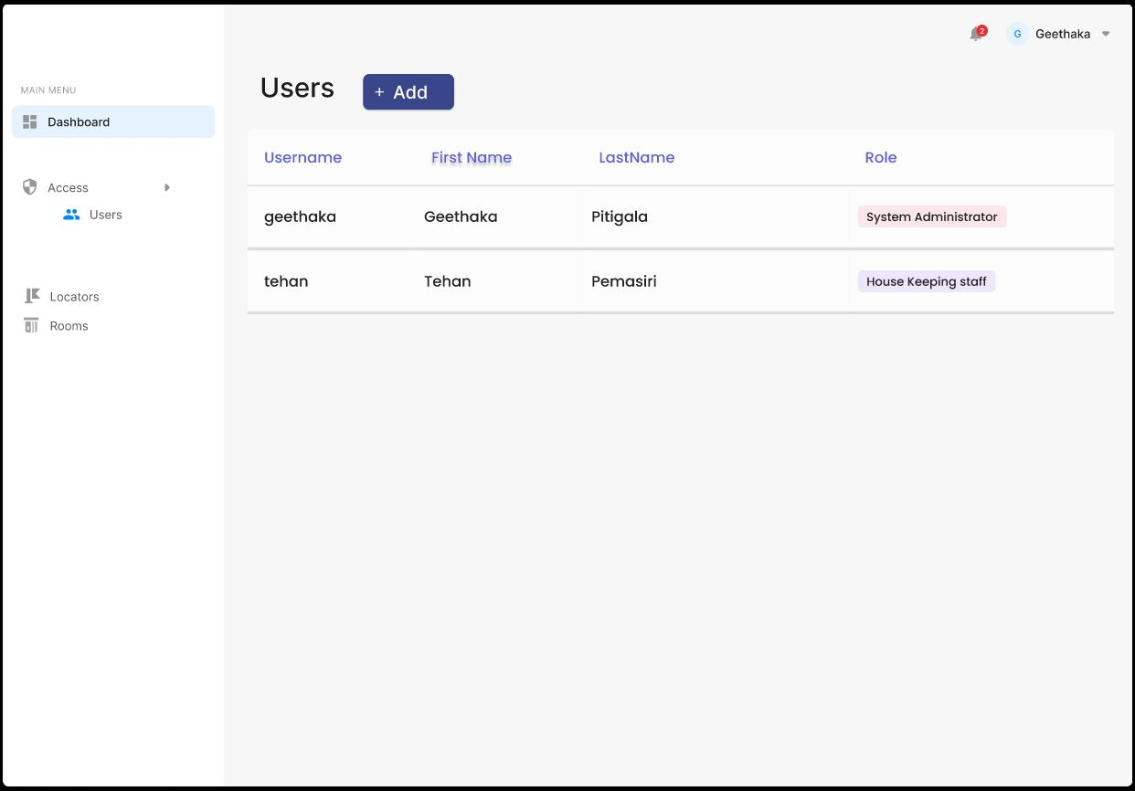

Figure .: Administration Portal 5

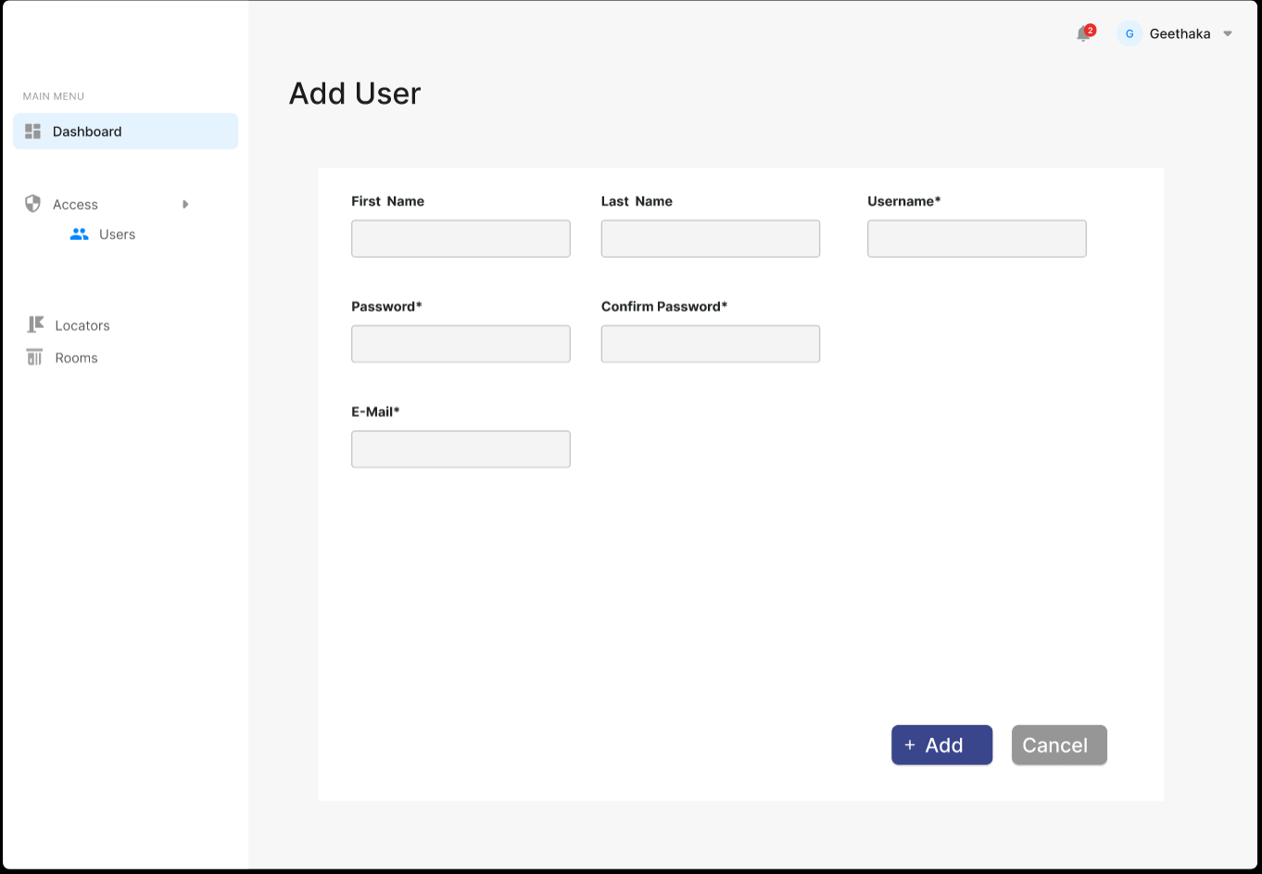

Figure .: Administration Portal 6

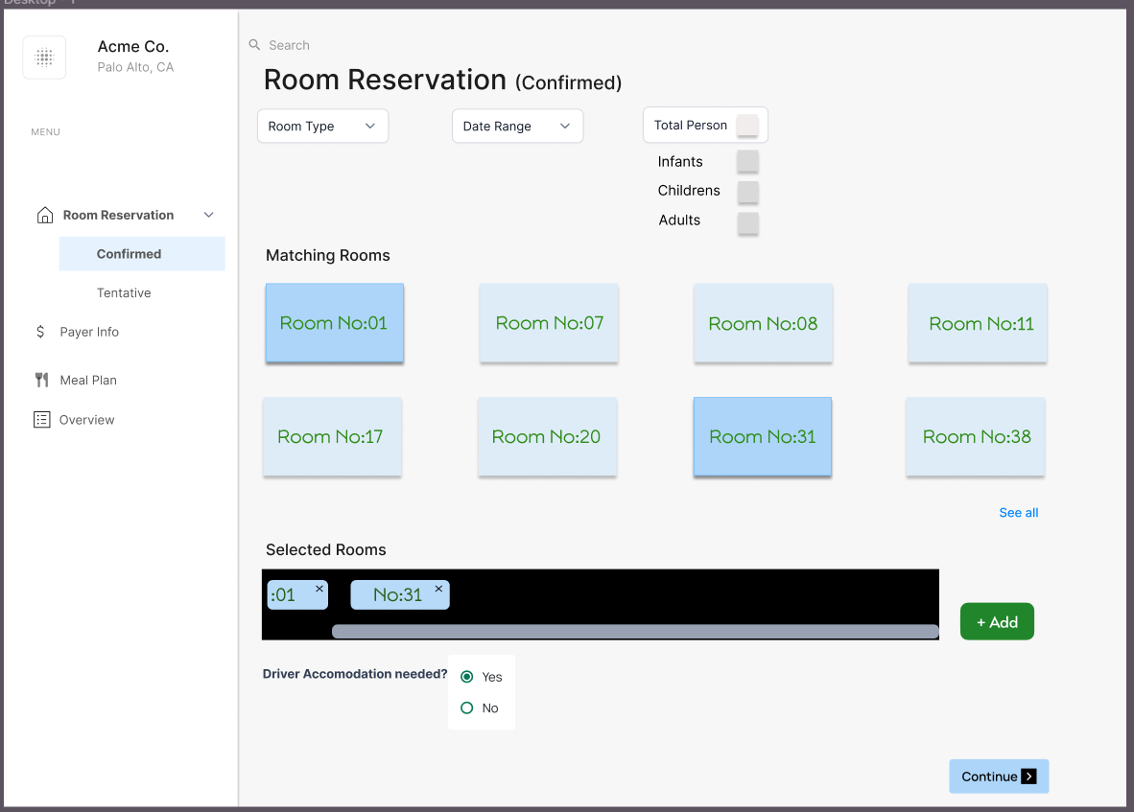Front Office Back Operations Portal

Figure .: Front office back ops 1

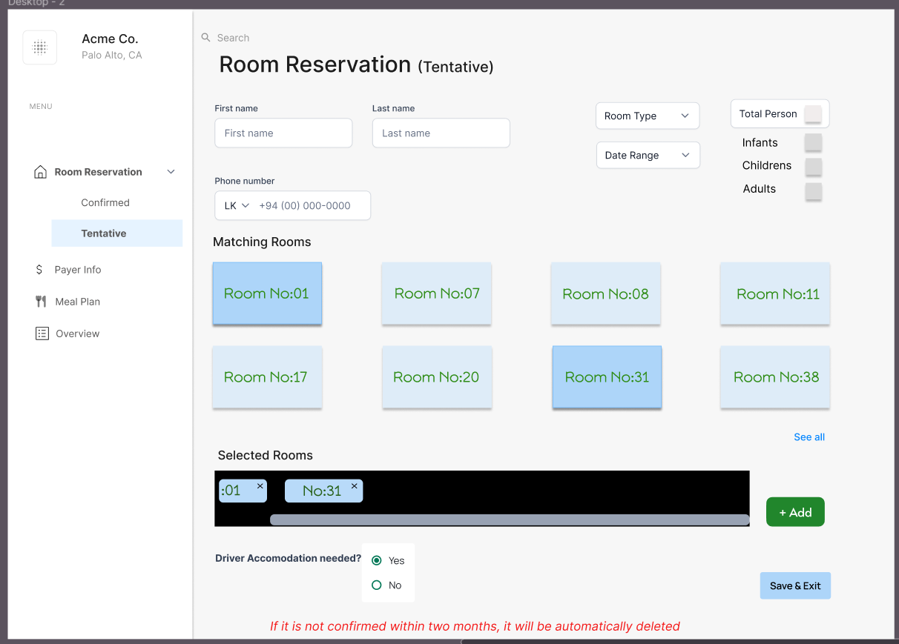

Figure .: Front office back ops 2

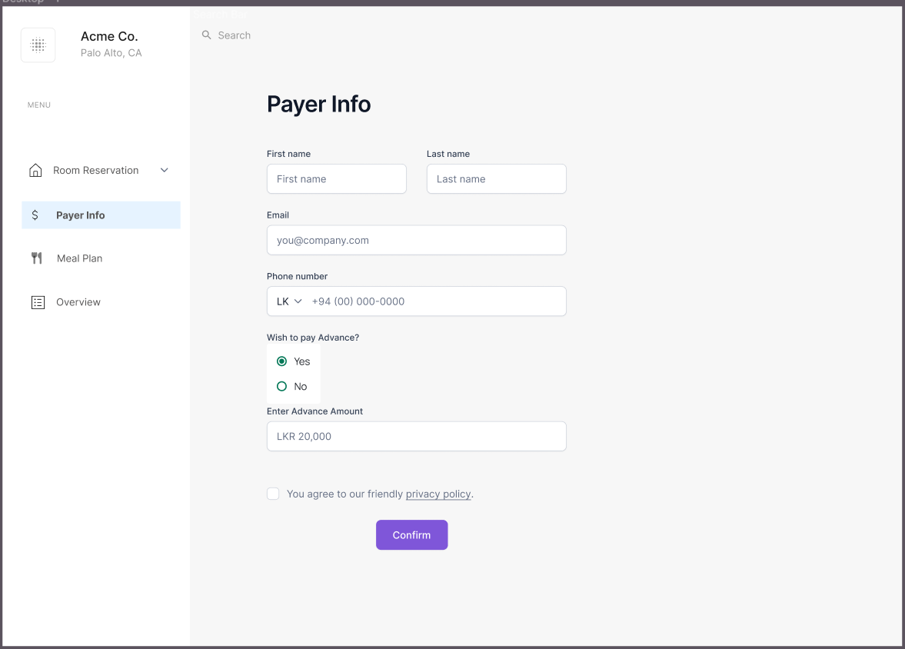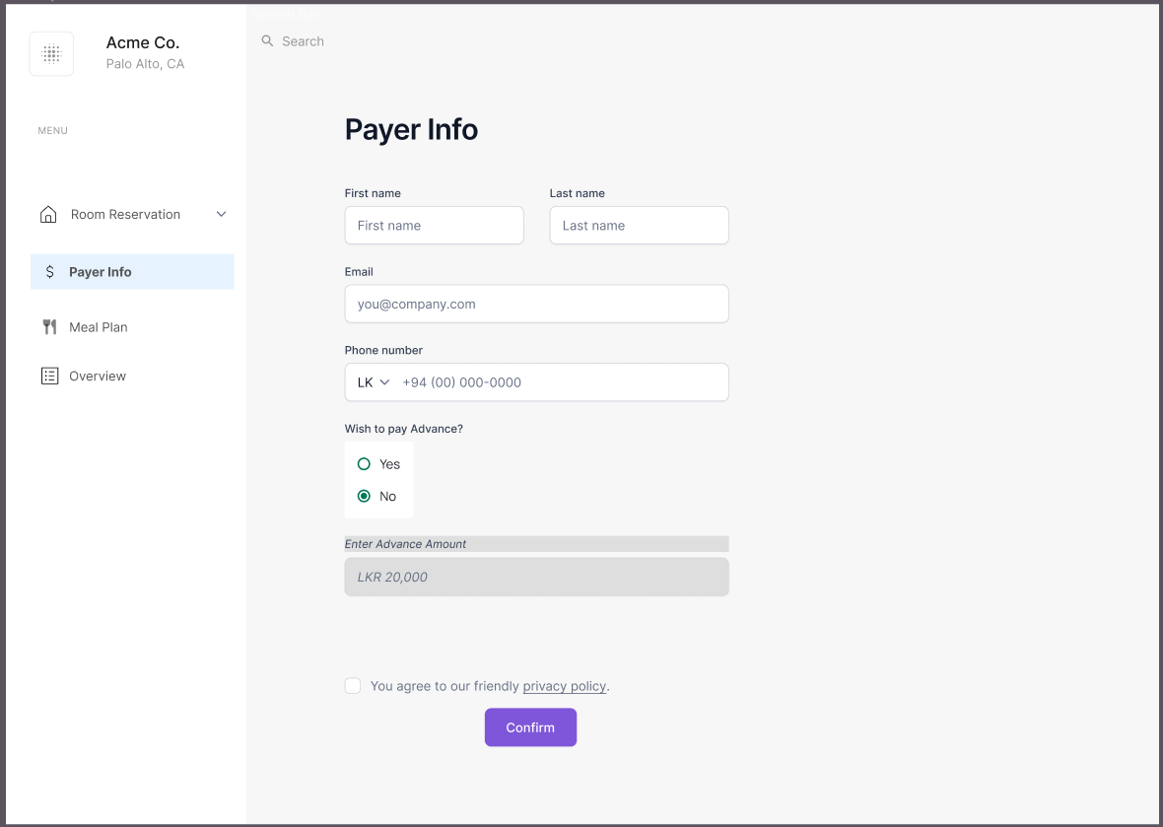

Figure .: Front office back ops 4

Figure .: Front office back ops 3

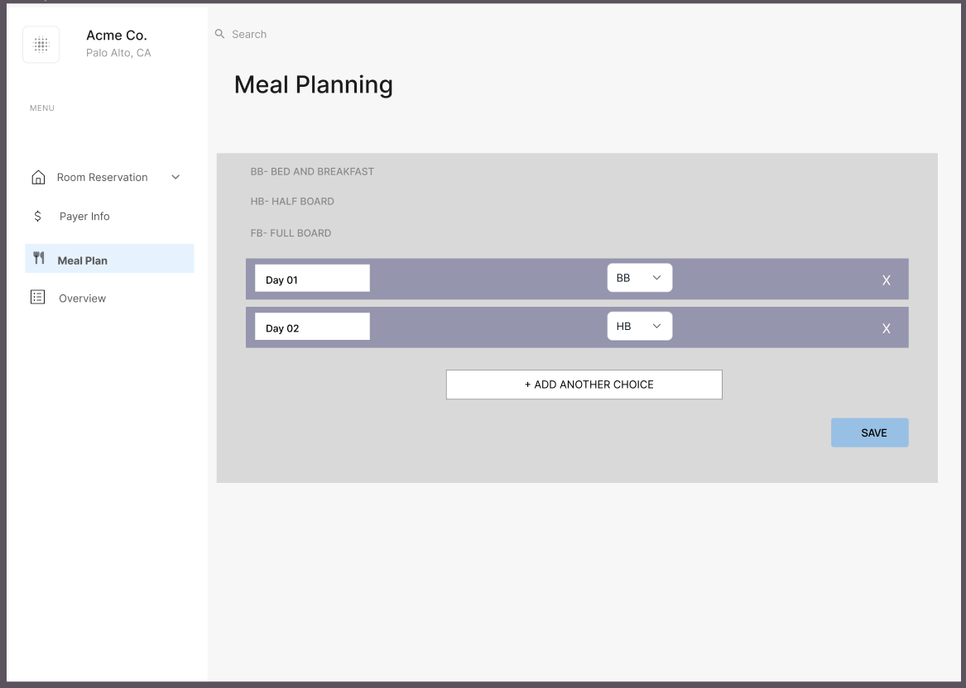

Figure .:Front office back ops 5

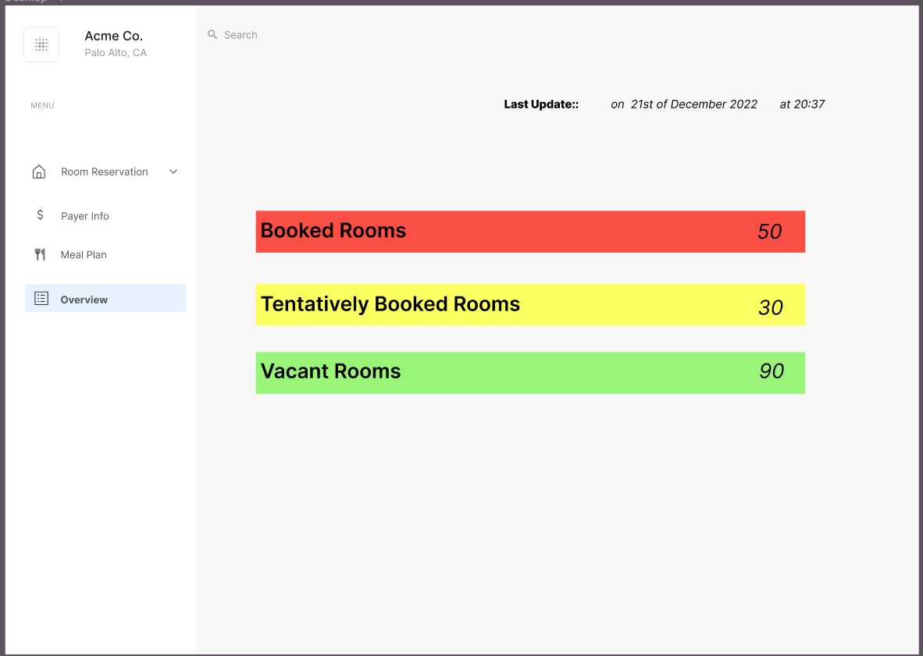

Figure .: Front office back ops 6

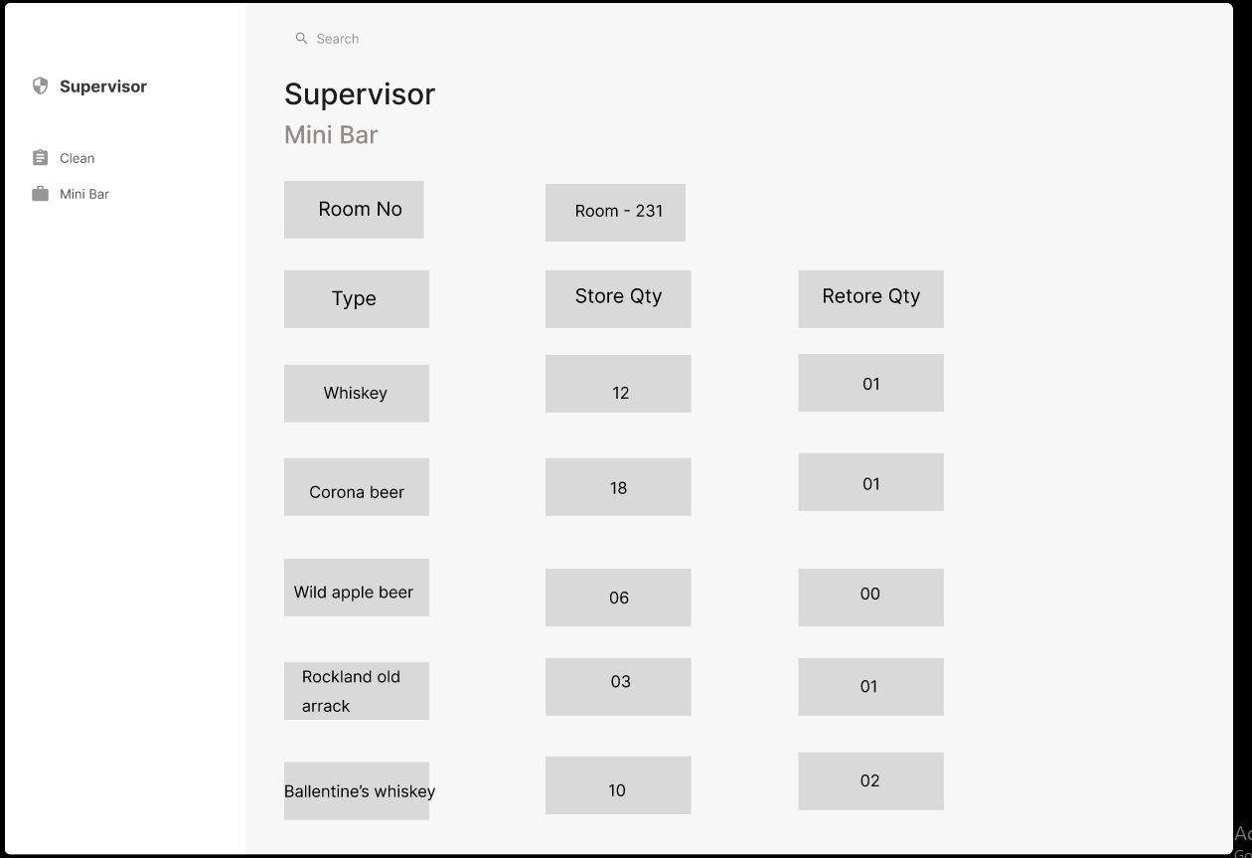House Keeping Portal

Figure .: Housekeeping 1

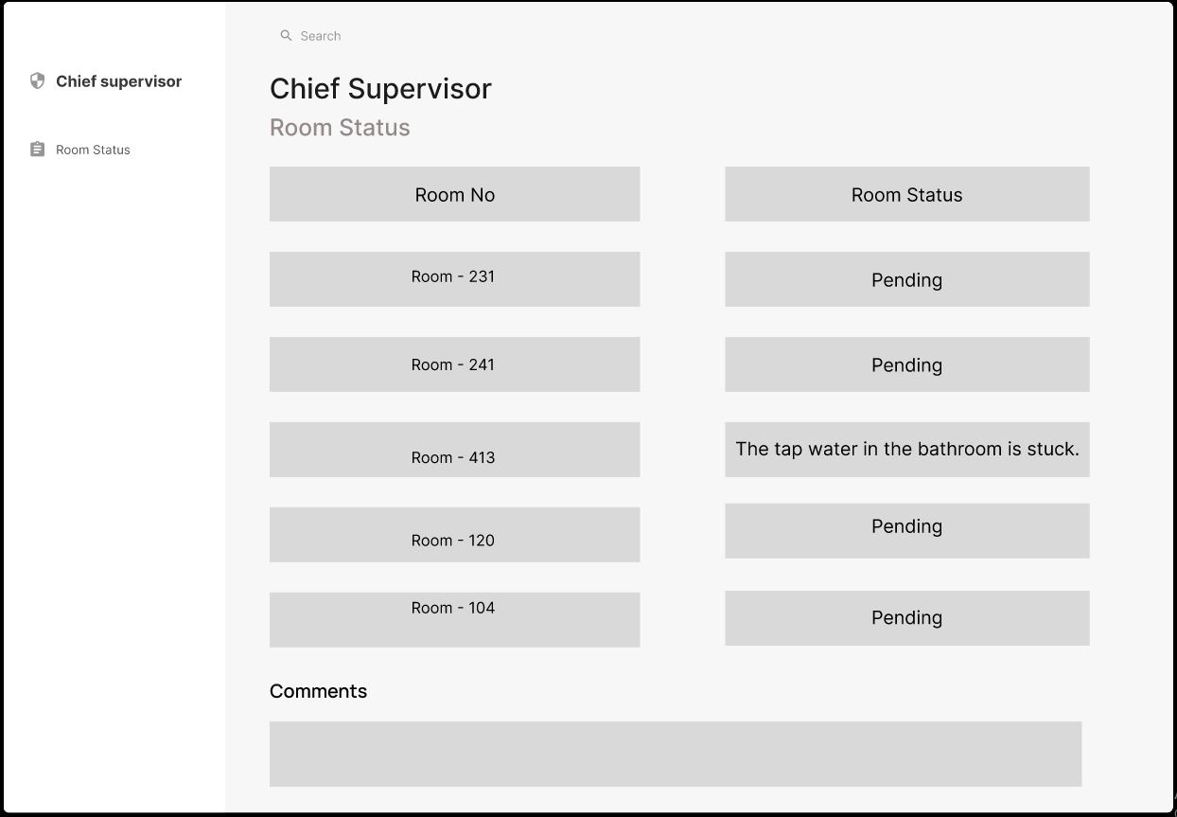

Figure .: Housekeeping 2

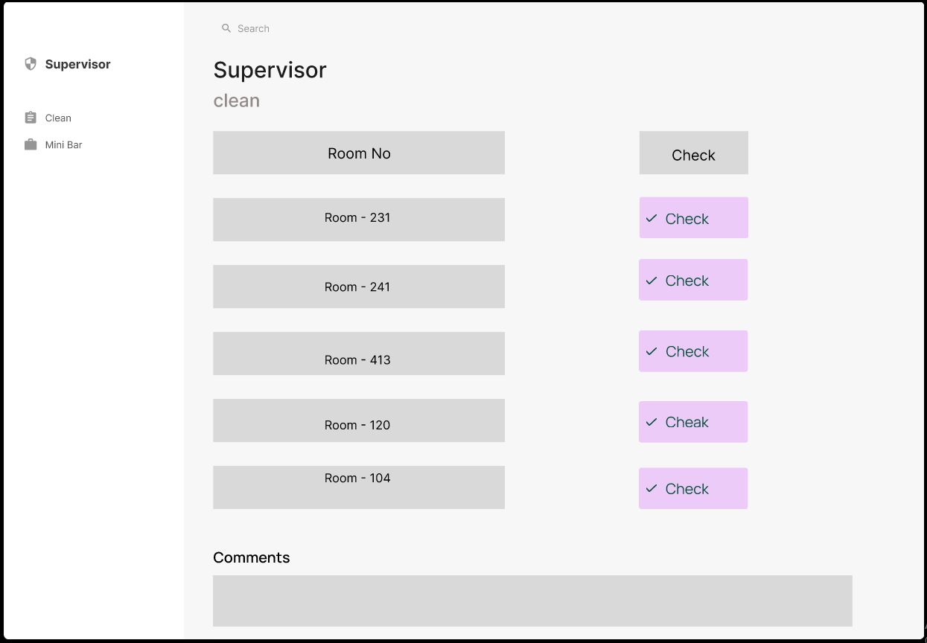

Figure .:Housekeeping 3

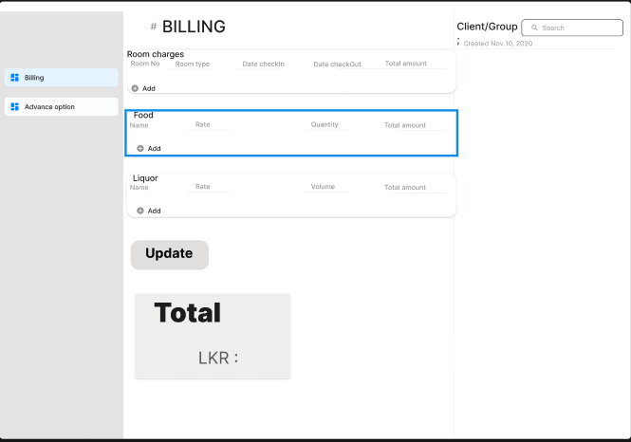Billing and Room Management

Figure .: Billing 1

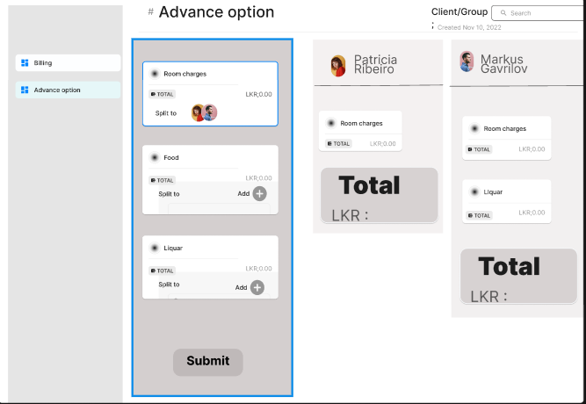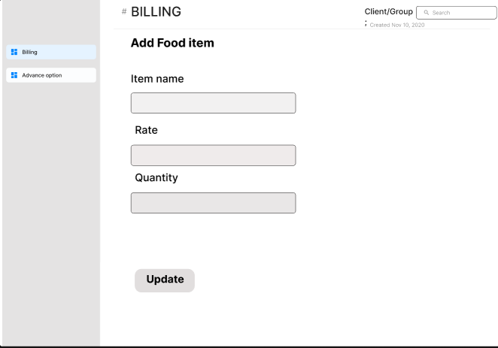

Figure .: Billing 3

Figure .: Billing 2

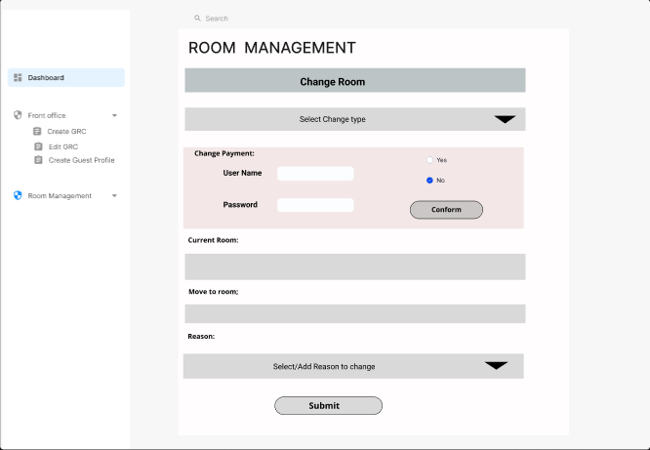

Figure .: Room Management

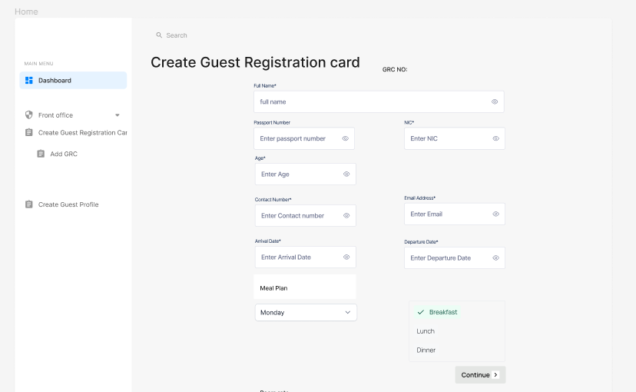Front Office Front Operation Portal

Figure .: Front office front ops 1

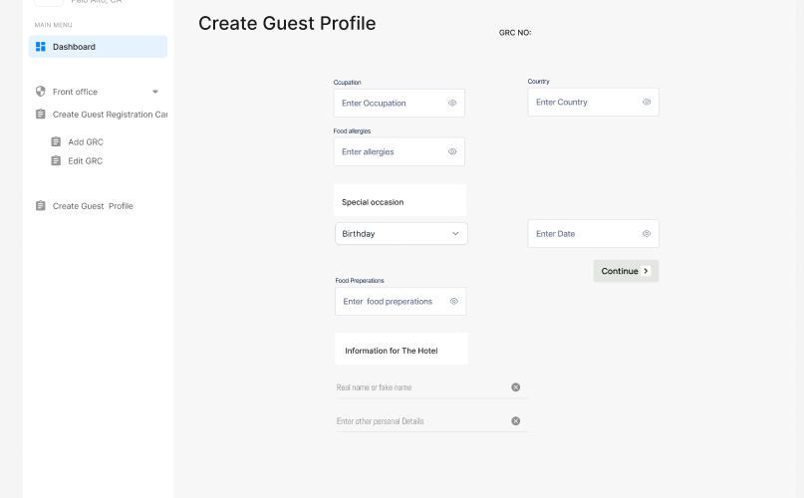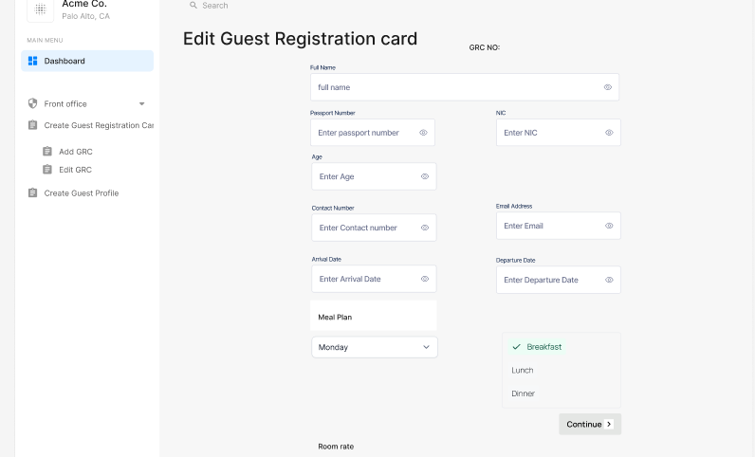

Figure .: Front office front ops 3

Figure .:Front office front ops 2